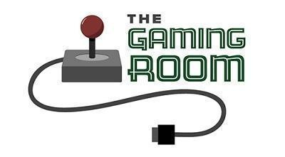

Draw It or Lose It

CS 230 Project Software Design Template
Version 1.0

Table of Contents

CS 230 Project Software Design Template 1
Table of Contents 2
Document Revision History 2
Executive Summary 3
Requirements 3
Design Constraints 3
System Architecture View 3
Domain Model 3
Evaluation 4
Recommendations 5

Document Revision History

Version | Date | Author | Comments
1.0 | <09/19/26> | Holly Withrow | <Brief description of changes in this revision>
2.0 | <10/04/26> | Holly Withrow | <Updating Development Requirements>
2.1 | <10/06/26> | Holly Withrow | <Added more depth to Development Requirements to fill it out more completely>
3.0 | <10/15/26> | Holly Withrow | <Recommendations made>
3.1 | <10/20/26> | Holly Withrow | <Added more depth to recommendations>

Executive Summary

The Gaming Room company wants a web-based guessing game that will render images for each team.
The number of teams allowed to play will be one (1) or more and each team will have multiple players.
The image rendered for each team will be completed within thirty (30) seconds which during that time frame the team assigned to the image will be able to make their guesses. There will be a library of images for the game to draw from.
Each image will be based on a phrase, title, or thing. Once the thirty (30) seconds is complete, if the team was unable to make the correct guess, then the other teams will be given fifteen (15) seconds to make their guess.
A multi-threaded program would allow the teams to make their guesses without stopping the timer or rendering of the image.

Requirements

- Technical Constraints
  - Web-based game available on multiple platforms
  - Each Game will be made up of one (1) or more teams
  - Each team will be made up of multiple players
  - Each Game and team names must be unique
  - Only one (1) instance of the game can exist memory at any given time

- Business Constraints
  - They wish the process to be streamlined

Design Constraints

- Multi-thread the program
  - Program can draw the image while also listening for user input if the team makes a guess before the thirty (30) seconds are up
- Programming Language: Java Script
  - very common programming language and free. If you want to later make applications for smart phones, this will help simplify the port
- Development Tools and Environment: React Native
  - open source and popular, good for turn-based games. Have to use React Native for Web framework if we use this framework

System Architecture View

Please note: There is nothing required here for these projects, but this section serves as a reminder that describing the system and subsystem architecture present in the application, including physical components or tiers, may be required for other projects. A logical topology of the communication and storage aspects is also necessary to understand the overall architecture and should be provided.

Domain Model

The diagram shown below is a structural UML diagram showcasing the relationship between the classes of Entity, Team, Game, Player, and GameService. Game, Team, and Player each inherit from Entity. Player has the relationship of zero (0) to many with Team and Team has the relationship of zero (0) to many with Game, meaning that when a Game is created it doesn’t have to have a Team assigned to it. GameService and Game also have the relationship of zero (0) to many.
GameService protects its constructor by making it private, using a static public method to access the constructor, ensuring that there is only one (1) instance of GameService active.
ProgramDriver uses SingletonTester, to test that there is only one (1) instance of GameService.

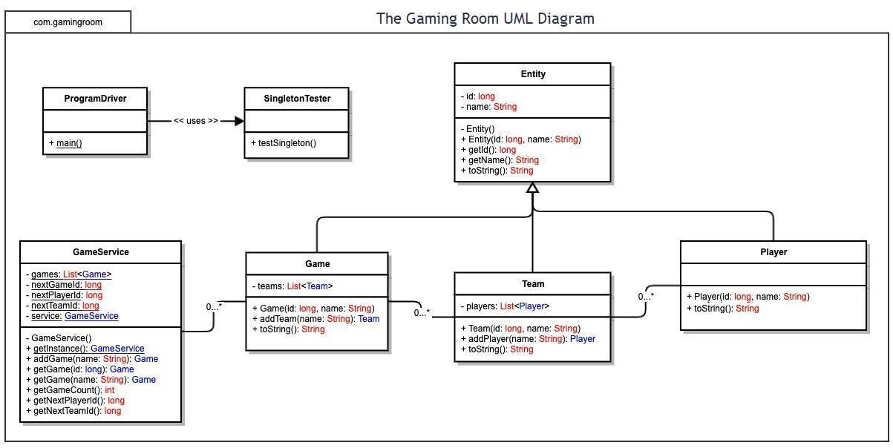

Evaluation

Using your experience to evaluate the characteristics, advantages, and weaknesses of each operating platform (Linux, Mac, and Windows) as well as mobile devices, consider the requirements outlined below and articulate your findings for each. As you complete the table, keep in mind your client’s requirements and look at the situation holistically, as it all has to work together.

In each cell, remove the bracketed prompt and write your own paragraph response covering the indicated information.

Development Requirements | Mac | Linux | Windows | Mobile Devices
Server Side | Unix-based OS that runs on Apple computers  Expensive hardware  Can host a Linux server through this device  Easy to develop and test locally  Has no server licensing options | Open Source  Built security features  Free options for licensing for hosting the server, such as Ubuntu  High learning curve when using it | Familiar system for many, created by Microsoft  Expensive licensing options  Good trouble-  shooting support from Windows | Impractical for hosting due to being more focused on individual users  Limited resources for hosting, unstable connectivity  Limited hardware capability
Client Side | Cost: High - expensive hardware needs to be purchased to develop and test the application  Time: Moderate, there is some added testing required for different browsers but it's not extensive.  Expertise: Low - Moderate, rather easy to develop in, low expertise needed but is still helpful | Cost: Low - Moderate, due to several tools being open source  Time: Moderate, there is still testing to complete for different OS but there are some programming languages that can help cut that down.  Expertise: Moderate - High, takes a long time to learn how to work in this OS, would need to find developers who are already knowledgeable if you don’t want to spend time training, high expertise needed | Cost: Moderate, easy to find people who have some knowledge of how to work in this OS. Hardware to relatively easy to acquire for moderate pricing  Time: Moderate, there is a good portion that can be shared across different OS.  Expertise: Low - Moderate, common OS, some expertise for Windows needed | Cost: Moderate - High, multiple developers will need their own physical devices or emulators  Time: High - Moderate, as there are several components to track such as different screen sizes or different touches on the touch-screen  Expertise: Moderate - High, again several components need to be taken into account so it may require someone with more expertise with Mobile programming
Development Tools | HTML, JavaScript, Python, Java  XCode, Visual Studio Code  Git, GitHub, Docker, Chrome/Safari developer tools | HTML, JavaScript, Python, Java, C/C++  Eclipse, Visual Studio Code  Git, GitHub, Docker, Linux Command Line | HTML, JavaScript, Python, Java  Visual Studio, Visual Studio Code  Git, GitHub, Docker, Chrome/Edge developer tools | HTML, JavaScript, Swift for iOS, Kotlin/Java for Android  XCode for iOS, Android Studio for Android, Visual Studio Code  Browser developer tools, React Native/Flutter, emulators for Android and iOS

Recommendations

Analyze the characteristics of and techniques specific to various systems architectures and make a recommendation to The Gaming Room. Specifically, address the following:

- Operating Platform: <Recommend an appropriate operating platform that will allow The Gaming Room to expand Draw It or Lose It to other computing environments.>

Linux Operating System (Linux) is a free open-source operating system that requires a higher level of expertise than Mac or Windows. Linux provides stability and security with a wide range of software tools. While it is still commonly used, it is not as easy to work with as Mac or Windows. Linux offers free hosting services for servers so while it is more costly to find personnel with knowledge in Linux, a large benefit is that it is free to use and distribute the operating system.

- Operating Systems Architectures: <Describe the details of the chosen operating platform architectures.>

A Layered Operating System structure offers modularity, security, and ease of debugging at the cost of performance overhead and strict planning for each layer is required. Since the layers are defined and don’t need to know exactly how the other layers are implemented, debugging and updating are made easier. Debugging can happen one layer at a time, starting from the lowest and once one layer is completely debugged, we can be assured it is good to move on to debugging the next layer. Each layer is also only concerned with its own functions so they don’t impact the others, which makes it easier to update as well. Since the layers cost more overhead as the instructions must travel through all the layers will slow the execution of said instructions down. The layered structure also requires a good deal of planning ahead with implementing the layers, so that the layers remain clear and neat.

- Storage Management: <Identify an appropriate storage management system to be used with the recommended operating platform.>

Network-Attached Storage (NAS) allows multiple devices to access and share the files stored within. The NAS device directly connects to the internet, via an ethernet cable. NAS devices often have backup features, helping the client to secure player data. Some negatives to consider for this type of storage are the following, the start-up cost is expensive since multiple physical devices need to be purchased and can consume bandwidth leading to increased network latency. There is a single point of failure, leading to the data being unable to be accessed should the NAS server fail. The NAS is complex to set, maintain, and troubleshoot, again requiring staff with the appropriate skills.

- Memory Management: <Explain how the recommended operating platform uses memory management techniques for the Draw It or Lose It software.>

Paging is a memory management system that uses ‘pages’, which are fixed blocks of memory, and pages are grouped into ‘frames’, all frames are the same size. Only the pages that are currently needed are loaded into memory, which can reduce external fragmentation. While external fragmentation is decreased, internal fragmentation can become a problem. Execution time of instructions can become slowed down if a page fault occurs, where information the computer is looking for is not in any of the active pages. Using the Least Frequency Used (LFU) page replacement, will drop the page that has least been used. LFU can cause a page to linger too long if it is accessed too frequently at first and then no longer accessed for a long period of time.

- Distributed Systems and Networks: <Knowing that the client would like Draw It or Lose It to communicate between various platforms, explain how this may be accomplished with distributed software and the network that connects the devices. Consider the dependencies between the components within the distributed systems and networks (connectivity, outages, and so on).>

Client Server Architecture is a network architecture consisting of a client (device that requests data) and server (stored and manages data, and responds to the client) with a request-response protocol (client requests and the server responds). This architecture centralizes data, making management and updates easier, can improve security, handle multiple clients at the same time, and ensures data integrity for all the clients since they are all getting data from the same place. Since the data is centralized, a couple of problems can arise if the server fails leading to a stop in services for all clients and a bottleneck can occur when too many clients are sending in requests at once. To ensure requests and responses are received and filled in a timely manner, using a four message protocol would make sure clients are getting their data though it will increase overhead some since the number of messages sent between client and server are doubled.

- Security: <Security is a must-have for the client. Explain how to protect user information on and between various platforms. Consider the user protection and security capabilities of the recommended operating platform.>

User authentication with a unique username and password are a common and easy way to provide security for the players. Two factor authentication is possible as there are many authenticator apps easily available but a problem that can arise should the player become unable to access the app for some reason, such as losing the device with the authenticator app. Having regular auditing and logging will help aid in catching mistakes or malicious acts. Such as logging password changes can detect if an account has been taken over by looking to see if the player requested the change or an administrator, encouraging accountability.

